Day trip to Valparaiso
Wednesday December 10 with Rick and Cathy and Mark

Sunrise 6:30am Sunset 8:50pm

Temps high 20-23 low 10-12.

Driving time: 1h30min at least let’s call it 2 hours

Stay for (early) dinner in Vina?

Morning in Valpo for a walking tour then eat lunch then get to Vina del Mar to see sights and walk on the beach boardwalk and eat a completo then bus back.

Transportation
Get there ourselves, by bus -
There are buses from the main bus terminal of Pajaritos in Santiago every 10 minutes, or you can book online via BusBud on popular days to ensure a spot.
https://www.recorrido.cl/en/bus/santiago/valparaiso/10-12-2025# don’t go on sale until closer so for now check other dates for times and price.
https://www.recorrido.cl/en/bus/santiago/valparaiso/10-11-2025# every 10-20 minutes 4000 CLP or $6 CAD one way

See

Valparaiso
Tourist area: Cerro Alegre and Cerro Concepción. Street art. El ascensor el Peral.
https://www.valpostreetart.com/classic-graffiti-tour.html $20USD pp for semiprivate 2.5 hours long. Or this, combines food https://www.valpostreetart.com/back-to-back-tour.html $50USD pp daily at 11am - 2pm. Oct 31: Sent a query via their web contact form, asked for times and quote. No response. Tried email on Nov 3.
https://www.patatourchile.com/daily-tours/famousvalparaiso
Nov 4: Went ahead and booked (via web form, no payment made) for 5 adults. 10 am tour They are very responsive on WhatApp.
They have a list of restaurants.
https://museomaritimo.cl/ 1 hour visit, good Google reviews but most info in Spanish? Nice grounds and views.

Vina del Mar
Is 30 minutes from Valpo. There’s a train along the coast get off at Miramar station.

Leave from Playa Caleta Portales station? Beach is nice to walk on? Sea lions, fish market.

For Viña I'd recommend you to go el Jardin Botánico, or just walk by the beach till you make it to Reñaca/Concon, by sunset is really pretty. Also playa negra and amarilla are pretty.

https://www.reddit.com/r/chile/comments/1j2hx9s/panoramas_en_vi%C3%B1a_por_el_dia/?tl=en has suggestions
- Quinta Vergara has beautiful gardens and the Vergara Palace is there. Site of famous song festival, unclear if it’s open year round.
- Cerro Castillo sector, there's a cool viewpoint and it's next to the flower clock. If you go to the flower clock, go up the stairs on the left side (facing the clock), you will reach the Cerro Castillo viewpoint, and it's different from just looking at the clock itself. (Cerro Castillo seems farther away??)
- Walk along the coast/beach, the whole walk from Av. Peru/Plaza Casino towards Reñaca is very calm and beautiful. You don't have to get to Reñaca, it's a great walk anyway.
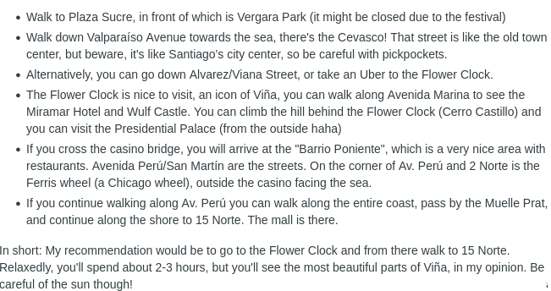

Eat Hot Dogs
Regarding completos go to Mahuel, they are not as big as Cevasco's, but they are amazing. It's a small place but it's the best completos place in the center imo.

Sibarítico - Anthony Bourdain went there.

El Guatón is better than Cevasco (another fast food, chain)

Miscellaneous
https://www.toursbylocals.com/tours/chile/valparaiso/tour-details/valparaiso-exploring-the-pacifics-jewel-664d252c1bbe5b817c353180

https://www.toursbylocals.com/tours/chile/valparaiso/tour-details/valparaiso-world-heritage-day-tour---santiago-chile-664d245517832fdc0dc208a5

https://www.businessinsider.com/visited-valparaiso-chile-best-city-in-south-america-2025-9

https://www.chile.travel/en/uncategorized/street-art-route-in-valparaiso-2/

Casablanca winery?
No. Would need to have private transport for the way back.

