Isla Magdalena notes
Monumento Natural Los Pingüinos run by CONAF La Corporación Nacional Forestal

There is only one way to access Isla Magdalena, and that is via boat. Most people that travel to the island go there via the Melinka, a public boat. This boat has a capacity of around 220 people, so if you prefer something less crowded this may not be the best option for you.
It’s a fairly boring ride alongside the distant shoreline of the Strait of Magellan for 35km
The excursions to see Magellanic penguins in Punta Arenas is good but it gets cancelled like 50% of the time.
Melinka - maybe replaced by Yaghan? See second photo
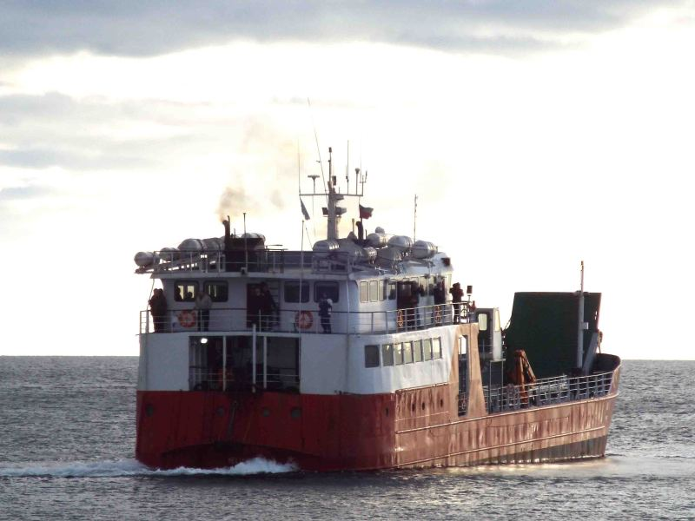
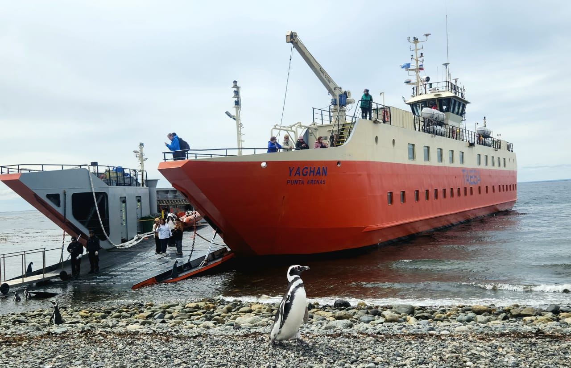
This looks like the Solo Expediciones boat speed 23 knots 120 pax
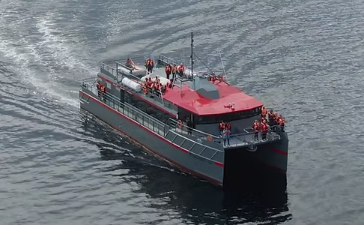
The inside of the Lighthouse is just an informative exhibit with the same stuff that’s on the brochure you can get on the ferry. That’s time much better spent hanging out with penguins, I think. Choose well, because about 45 minutes after landing the conservation staff begin actively herding people back towards the boat.
about two hundred visitors coming per day in high season
The alternative is to take a private boat. If you choose this option, it may include snacks and drinks on the boat -depending on what is included in the cost. All the boats will depart from the Tres Puentes Terminal in Punta Arenas. The times depend on whether you choose the ferry, or a private boat.
---
Magdalena Island (Isla Magdalena) is a small island approx. 35 kilometres off the coast of Punta Arenas in the Straits of Magellan and there are two ways to get to Magdalena Island. You can take the public ferry (55,000 CLP or US$ 80) that leaves from Punta Arenas at 8am or join an organised tour on a private speed boat (approx. 1-hour ride one-way from Punta Arenas).
https://www.comapa.com/en/tours/penguin-tour/ $106 USD
https://www.soloexpediciones.com/tours-excursiones?lang=en $118
The public ferry is cheaper (buy your tickets online but takes 2 hours one-way and you only have an hour to walk around on the island. For us, one hour on the island was enough (it’s not that big), but if you think you might want more time with the penguins, transfer from/to Punta Arenas included, and a knowledgeable tour guide, consider joining an organised tour (operating October to March). The ferry to Magdalena Island leaves from Tres Puentes Pier next to the ticket office, a 10-15 min drive north of Punta Arenas city centre.
https://www.reddit.com/r/Patagonia/comments/1idifuf/day_trip_from_punta_arenas_to_isla_magdalena_to/
How to get to the ferry wharf? It’s called Pier Prat? Do all boats leave from the same place?
Some trips include Isla Marta (sea lions) some not. Slower boat = more chance of whales maybe.
... the time that tourists can spend on the island is strictly limited to only one hour.
Saturday December 6th is our day, we fly out from Punta Arenas on Dec 7th.
Company | Cost | Departure time | Boat | Duration | Isla Marta?  For sea lions | Notes
Solo Expediciones | $118 USD | 06:30 | MAGALLANES 500 CATAMARAN | 4.5 hours | Yes | Meeting in town, includes transfer to dock  Booking is via email contact form.  20-May: sent query for 4 people not sure about Mark
TABSA public ferry | $85.000 CLP approx $90 USD |  |  |  |  | May 18: Tried to click through booking, says not (yet?) available  Also this Reddit post (1 year old) says “not running anymore”. Seasonal or permanent?
Turismo Comapa | $106 USD | 09:30 | Yaghan | 5 hours | Not mentioned | Same as TABSA? Website says the ship is Yaghan, same as photo on TABSA site. Also can’t book yet. Could contact them to find out.
Fiordos del Sur | 130.000 CLP with pickup, cheaper without | 7am | Looks like a catamaran | 5 hours |  | No, not good Google reviews
Denomades | 105.000 CLP per person. With pickup and snack |  | Catamaran | 4.5 hours
Todo Patagonia | $140 USD with pickup

How to get to ferry terminal
Note from a Reddit post: Uber was super cheap in Punta Arenas
The Tres Puentes ferry dock is about 7km from the Plaza del Armas, so you’re probably gonna need a ride. Collectivo #15 runs from the harbor side of the Plaza for 800 CP, or a taxi should be able to take you for a few thousand.
While you can purchase tickets from travel agents around town, you may as well buy them straight from the COMAP office (permanent address 990 Magallanes just off the Plaza, temporarily at 1112 Lautaro Navarro a few blocks south). If you’re visiting in high season it’s worth checking into reservations, as they do regularly sell out.
This Reddit post suggests ferry is cheaper and better than private tours
https://www.reddit.com/r/Patagonia/comments/1idifuf/day_trip_from_punta_arenas_to_isla_magdalena_to/

Plan B
Alternative if we can’t do penguins due to weather - (but can we book last-minute?) $35 USD pp half-day or just take an Uber, figure it out on the day
https://todopatagonia.net/en/tour/fort-bulnes-half-day-tour-strait-of-magellan-park/

