General

Sunrise/sunset
Puerto Natales on Nov 20
Sunrise 5:40 am
Sunset 9:30 pm

Time zones
Santiago has summer time. Is GMT-2 in winter and GMT-3 in summer.
No summer time in Magallanes Region - it’s GMT-3 all year long. (Since 2017)
Argentina is GMT-3 all the time.

==> 2 hours ahead of Ottawa when we'll be there

Passports
D AA674363 Exp 12 Apr 2027
A HB906576 Exp 7 Oct 2025 (old)
A P990979ED Exp 07 May 2035 (new)
R AR029493
C HN379287

D Aeroplan 145267225
A Aeroplan 145464657

Airalo pw

Torres del Paine
Sites to check to see if Los Torres booking is open:
https://torreshike.com/blog/torres-del-paine-reservations-for-season-2025-2026/ aggregrator
https://lastorres.com/donde-alojar/camping/ official site

Lineups!
Hikers queuing up to enter the park at the Laguna Amarga entrance.
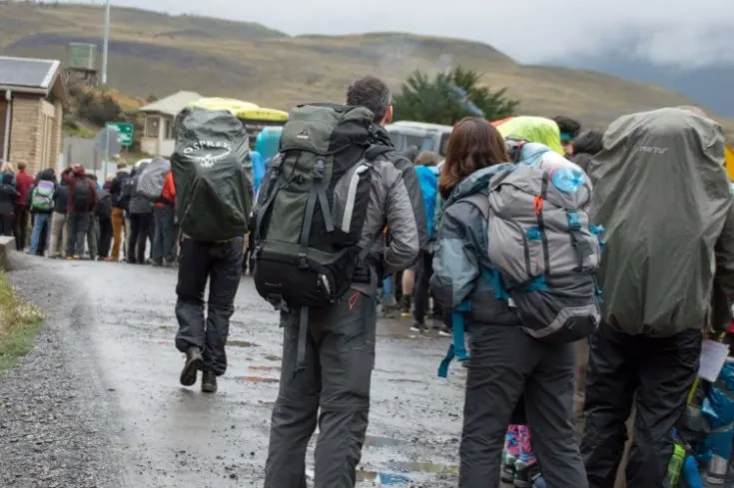

Booking cancellation policies
https://torreshike.com/blog/torres-del-paine-cancellations-bookings-changes-season-2025-2026-2/
Free cancellation up to 90 days ahead of reservation

Campsites
Post describing exactly our trip.
https://www.reddit.com/r/Patagonia/comments/1iu58a2/w_trek_w_to_e_completed_full_details/

More campsite reviews - this guy did El Chileno - I think we should do that too
https://www.reddit.com/r/Patagonia/comments/1gc8fg0/w_trek_east_to_west_5_days_camp_breakdown/?chainedPosts=t3_1blxe1k

https://backcountryemily.com/ocircuit-cam)pground-guide/
Frances Camping area: The camping area is up on a hill and on platforms only. I had no issues setting up my non freestanding tent. Plenty of rocks around for guylines and the platforms have hooks and nails around the sides to loop your guylines on.

But, I’d stay at Frances if doing the W towards Paine Grande. It sets you up better for the Britanico climb.

https://worldlyadventurer.com/camping-in-torres-del-paine/
Grey is smaller than Paine Grande and so is more likely to be booked up.
Paine Grande is located just next to where the catamaran ferry that crosses Lago Pehoe arrives and is a useful campsite as it’s big (and so normally has space)
Camping at Francés and Los Cuernos is on raised wooden platforms, with some shelter from bushes and trees. If staying here, I recommend bringing some string to help with putting up your tent. Although there are hooks in the wooden platform to be used instead of pegs, it can be quite hard to pitch your tent well.
El Chileno is situated at the base of the towers, but a couple of hours closer than Torre Central, meaning you can hike from there up to the towers at dawn. Camping is on raised wooden platforms, with some shelter from bushes and trees. There is nowhere to leave your rucksack at this campground; if you plan to head up to the towers, you’re best to do this for dawn, leaving your tent up with your stuff inside. When you come back down from the towers, you can pack up. Check-out is at 9am.
But - another site says There is also a small covered ledge at Chileno to the right of the restaurant door for leaving packs.

Bus schedules
2024/25 peak season schedule, assume same for 25/26
https://www.bussur.com/wp-content/uploads/2024/10/TEMPORADA-ALTA-INGLES.pdf

Punta Arenas to Puerto Natales 3h15min 12.000 CLP $17 CAD
7, 8:30, 10, 11, 12:30, 14, 15, 17, 18, 19, 21

Puerto Natales to TDP (Laguna Amarga) 14.000 CLP $20 CAD
7 arr 9, 12 arr 2pm, 14:30 arr 16:30
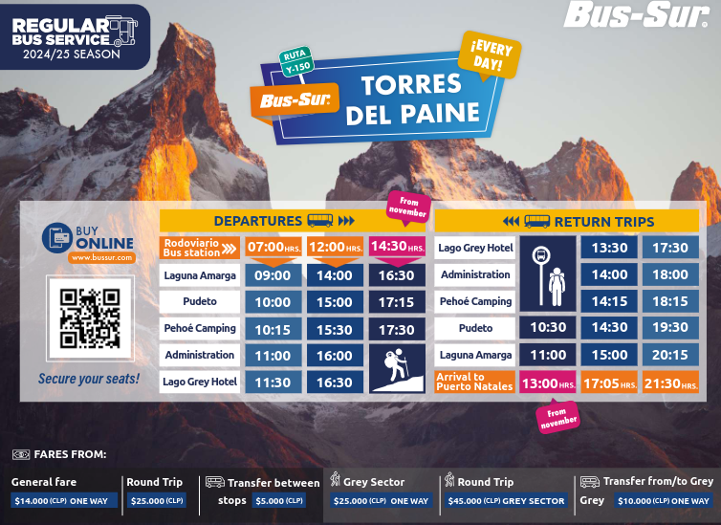

Shuttle from Laguna Amarga
https://helpcenter.lastorres.com/en/help-center-las-torres-patagonia/regular-buses-to-the-hotel
If you arrive by regular bus to Torres del Paine National Park, we offer a private shuttle service for our hotel guests and a public shuttle service to the Backpacker Welcome Center. This shuttle service will take you to the hostels, camp sites or to the beginning of the W Circuit and O Circuit. The shuttle services are by prior reservation.

Catamaran schedule
We’ll take this the first day in the park to get to Paine Grande
https://catamaranpehoe.com/inicio
Schedule for Nov 2025 not listed yet. Can buy from August 4.

Found this from a third-party
https://torres-del-paine.org/torres-del-paine-w-trek-2/catamaran-torres-del-paine/
From Paine Grande: 09:20hrs / 11:20hrs and 18:40hrs

BusSur buses from Pudeto: 10:30, 14:30, 19:30 2.5 hours to Puerto Natales

Nice short hike Salto Grande waterfall near Pudeto, can extend to Mirador Cuernos if there’s time

Btw since you have some time between the ferry and the bus, you should also check out the Salto Grande waterfall and Cuernos viewpoint. Both are better than the Grey viewpoint IMO. Very easy and flat trail, about 1-1.5hr round-trip from the Pudeto dock/bus stop.

As I had time to kill, I hiked to the Mirador Los Cuernos (3 miles roundtrip easy hike from the Mirador Salto Grande, which was about 2.5-3 miles roundtrip from the Pudeto bus stop). The Mirador Los Cuernos is the prettiest short hike I have done in a long time, well worth it if you have energy and time to kill at the ferry stop.

Lago Grey boat schedule
n/a for us

https://www.lagogrey.com/en/navigation/
$100 USD
11am arr 12:45
1400 arr 15:45
1745 arr 18:45

BusSur buses from Lago Grey: 13:30, 17:30, 3.5-4 hours to Puerto Natales

https://www.reddit.com/r/Patagonia/comments/11yupu2/getting_to_refugio_grey/

Other things to book
park entrance,
torres del paine entry ticket, www.pasesparques.cl
DONE October 13

Packing checklist
https://www.mount-patagonia.com/poincenot-torre-trek

Provisioning
https://worldlyadventurer.com/food-hiking-torres-del-paine-national-park/
The one UNIMARC supermarket in Puerto Natales isn’t huge and definitely limits the amount and variety of food that you can buy. If possible, provision in Punta Arenas where there are a large number of supermarkets, all stocked with an excellent range of foodstuffs – and at significantly cheaper prices.

But we won’t be spending any time in Punta Arenas. Land then onto bus immediately. So stuck with Puerto Natales.

Car Rental
See Car Rental Notes.

Puerto Natales

Eat
la guanaca - very nice food, lot of options on the menu for all dietary wishes
Holaste is a cute cafe and has very good coffee (but gets crowded)
Mesita grande also has nice food

Restaurante Los Coigues "Jechef".

Santolla splurge, excellent crab

Avoid Baguales brew pub

Do
Walk around.

El Calafate

Eat
Where to eat in Calafate
https://www.reddit.com/r/Patagonia/comments/1iu2tbj/food_in_el_calafate_where_to_eat_in_el_calafate/

Buenos Cruces Pasta Bar

Miguels
Lucinda Casa de Campo the owner, a gentleman called Miguel, cooks up a wonderful asado in his backyard most evenings. You’ll get a welcome vermouth, lamb empanadas baked in the stone oven, choripan, a nice cut of steak (we got vacio when we were there), dessert, and unlimited Patagonian wine. There will be a group of 15-20 people there and the goal is for people to mingle during arrival drinks and at the communal tables. We met some pretty cool people, and Miguel’s hospitality was very good (constantly offering more food, a wine top up, etc). It was USD 70 cash only per person, but he also accepted EUR. It felt like being invited by a friend to their house for a barbecue.

Do
Do something in the morning before glacier afternoon?
https://www.reddit.com/r/Patagonia/comments/1o5sgxk/el_calafate_itinerary_for_2_full_days/

The Laguna Nimez Reserve you can visit independently, has more birds in one place than I saw in all of Patagonia put together beforehand.

El Calafate estancia nibepo aike - sheep farm 1h20 drive from town sort of in direction of glacier but off on a side road. Looks like more of an overnight place with activities like horseback riding, sheep shearing, food.

The ice museum Glaciarium open noon to 7pm. 10 minute drive in direction of glacier.

Punta Walichu 8km out of town east along the lake, cave paintings and nature preserve open 9am to 8:30pm. Guided tour 10:30, language tbd
Audio guide available in English https://puntawalichu.com/audio-guia/ seems well done from the first few minutes I listened to.

Los Glaciares
Los glaciers park site and map in English
https://prothos.com.ar/pnlgzn/index_en.php?fbclid=PAQ0xDSwJ4Vv9leHRuA2FlbQIxMAABp9DdGHwfY70qmnePKgZ9gJ_efoEgQLkTTeM1ICmtfpujlOZanbyZ7Er-Vlak_aem_4NQ4ArAFyDz9ras8DOvNUQ

Perito Moreno Glacier
https://notesfromdreams.com/2024/12/06/your-ultimate-guide-to-visiting-perito-moreno-glacier/

Unclear if you can do both Moreno and the other glaciers by boat the same day. I’m thinking we’ll do Moreno self-guided, with optional 1-hour boat ride. Otherwise we’re paying through the nose and are beholden to someone else’s schedule for seeing Moreno.

We got there late around 330 and was not too touristy. Take the red walkway, it is pretty short but most people avoid it. Best view of our entire trip.

see Moreno end of day - the park is SO much emptier at the end of the day and such a better experience

Pro tip: arrive at 4pm. Almost everyone leaves by 5pm and you can stay til 8pm.

A couple of tips:

About 1 km after the park entrance there’s a clean rest area with bathrooms and beautiful lakeside views — perfect for a picnic. It’s usually empty, and there’s plenty of wildlife around (try not to feed them).
Arrive at the park after midday. Around 3 p.m. the tour buses start leaving, and by 4 p.m. you’ll have the park almost to yourself. The gates are open until 8 p.m., and the days are very long.

https://ripioturismo.com/wp-content/uploads/2021/05/perito-moreno-trails-map_Mesa-de-trabajo-1.jpg.webp
To do, replace link with image itself when on the laptop.

Best to start at the bottom right parking lot (blue/Coastal trail) and then continue along the yellow and red trails. If you're on a tour, they'll likely pick you up from the main parking lot (in the middle). If you're using a rental car, there are shuttles between the parking lots (or you walk back). All of those trails are boardwalks (with stairs).

Park entry fee
https://ventaweb.apn.gob.ar/reserva/FTE

3 options:
- Flexipass Los Glaciares A single, non-transferable pass, under which visitors can select between 3 or 7 days of access, depending on their category, to be used within 6 months of purchase, consecutively or alternately, and within the same protected area.
  - Flexipass x3 General $90000 -> $110 CAD
  - Flexipass x7 General $157500 -> $192 CAD
- Portal de acceso corredor Río Mitre y Glaciar Perito Moreno - Parque Nacional Los Glaciares. Located 50 km from the city of El Calafate, it is the access route to the walkway area overlooking the Perito Moreno Glacier and provides access to tourist activities related to the glacier.
  - General $45000 -> $55 CAD
  - General (Pase Promocional de dos días) $67500 -> $82 CAD
- Portal de acceso Puerto Punta Bandera - Parque Nacional Los Glaciares. Located 45 km from El Calafate, it is the embarkation point for lake excursions to the northern arm of Lake Argentino, where visitors can observe glaciers such as Upsala, Spegazzini, Heim, Seco, Mayo, and others. PURCHASE THIS TICKET ONLY IF YOU ARE TAKING LAKE EXCURSIONS. THE PURCHASE OF THIS TICKET DOES NOT INCLUDE EXCURSIONS. BEFORE PURCHASING THIS TICKET, YOU MUST ENSURE THAT THE APPROPRIATE EXCURSION SEATS ARE AVAILABLE.
  - General $45000
  - General (Pase Promocional de dos días) $67500
Can’t buy it for November yet. Prices are for May 2025.

We’ll need it for some hikes in El Chalten. People have said if you go before 7am the pass is not checked.

1 day - glaciers
5 nights -> 4 days hiking

I’m thinking the 3-day pass will be good. We can pick 2 hikes outside the park.

Many complaints about the fees: The facilities are non-existent on the trails, comparing the hole in the floor metal toilets on the $45 national park trails to the practically hotel quality, private cubicle toilets at the $10 Huemul Glacier trail

El Chalten
Windy/dusty
https://www.reddit.com/r/Patagonia/comments/1hm2gr1/i_just_did_5_days_in_el_chalten/
Summary - food is expensive
https://www.reddit.com/r/Patagonia/comments/1htmnv3/just_finished_tdp_chalten_calafate_ama/

Overview map from https://prothos.com.ar/pnlgzn/index_en.php:

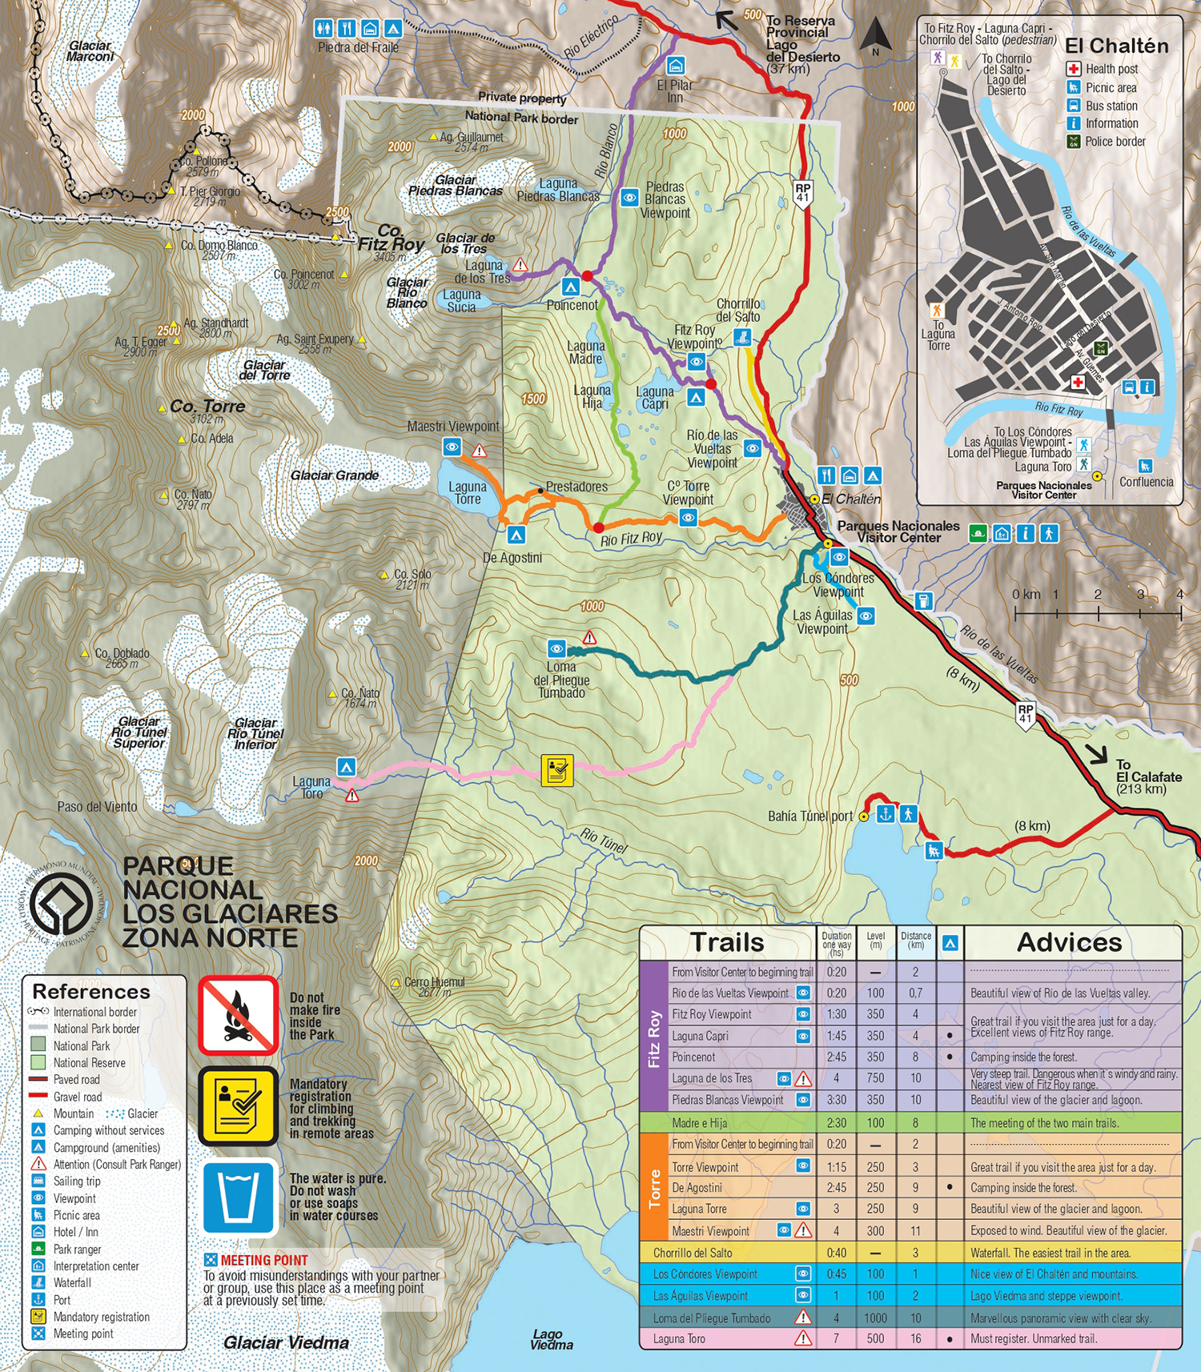

Hikes
If only 2 days in Chalten, do Fitz Roy aka Laguna de los Tres one day and Laguna Torre the next. I actually preferred Loma del Pliegue Tumbado. The final 360 view is insane (pic).

Note Fitz Roy has a one way route with shuttle or hitchhiking to get to Rio Electrico trailhead. Add side trip to Piedras Blancas Glacier viewpoint.

I recommend you also do Laguna Sucia on the way back from Fitz Roy, it was my favourite thing there. Gives you a little taste of solitude when you break away from the crowds

If you are comfortable scrambling, Loma de las Pizarras.
https://www.wikiloc.com/hiking-trails/loma-de-las-pizarras-33282084 19 km 1500m blend of the two main trails

Piedra del Fraile
View of Fitz Roy north face. Small camp ground. A very nice and sheltered hike. If you go beyond the refugio, be prepared for more serious wind.

Cerro Madsen - no, rock climbing

Huemul glacier, we were the only ones up there and it has spectacular views. Lovely blue lake as well! Can be done no matter wind and rain.

Short hikes
Laguna Capri! It's short and easy. Side trip to Cascada Escondida we didn't see another soul there around 17:30/18:00 (it's not signposted, so most people just continue on the main trail).

Check out the El Paredon view point trail This is a lovely little walk to do when you first arrive in El Chaltén. The viewpoint from Cerro Paredón offers a beautiful preview of the area’s splendor, with panoramic views of both the village and the surrounding mountain range. It's a lesser known trail up above the town. Really nice view and not as many people.

Mirador el chalten - observation deck on the road into town

Mirador Condor y Aguila (can be crowded)

Huemules Reserve
Hut
https://refugiosdepatagonia.com/en/puesto-cagliero-en/
Crepes and dulce de leche? A bonus if it works out

The hike I’m interested in:
https://elchalten.com/v4/en/laguna-diablo-puesto-cagliero-trek-los-huemules-el-chalten.php
https://www.loshuemules.com.ar/senderos/sendero-valle-del-rio-diablo/

Somewhere it says you need to prebook entrance the day before as there are limited tickets? CAPACIDAD DE CARGA: 100 PERSONAS POR DIA.

19,000 per person -> $20 CAD
The site currently says 36,000 per person -> $35 might have gone up

https://www.loshuemules.com.ar/

WHATSAPP +54 9 2966-76-2843. Every day from 9 to 18 hours. We will help you manage your reservation, but remember to do so in advance with up to 24 hours and within public service hours (9 to 18hs).

Stay

Eat
Asadores for dinner in El Chalten. $55 prix fix for 5 courses. Order 1 meat and 1 veggie “track”as the portions are huge into much meat otherwise. Great food. 2 seatings per night so books up.

Bandidos Patagónicos

La Lomiteria sandwiches and fries

Empanadas at La Roti were the best. I recommend taking 2 or 3 on your hikes. They were well-seasoned and large enough to be a good meal. The guanaco one was amazing as well as the one with carrots and blue cheese.
Paisa coffee shop

Punta Arenas

Stay
Delmoro b&b
12 minutes from bus
Quiet neighbourhood? We’re there Friday and Saturday nights. “far enough from busy areas to be quiet”

Room 6 Because it is a B&B/hostel-style Airbnb, there is quite a bit of foot traffic going in & out which can be noisy at times. I think this is a great place for a night or two, but not the most ideal for a full week. Carlos provides a nice breakfast of yogurt, breads, coffee, etc which was wonderful, however, we didn’t have access to a full kitchen so we had to eat all other meals out.
Our room was well kept & very comfortable. A few things to keep in mind are that the room faces the road, so cars can be heard throughout the night and the room gets very bright once the sun is up.

The shared kitchen was well equipped and there were even basics for breakfast (we didn’t use it because we had to get up early both days). Carlos is a friendly person. The street in front is very busy, but I would definitely recommend the accommodation. But another reviewer said: conveniently located in a quiet area

Do
Mirador Cerro de la Cruz
Cabo Froward
Museo Nao Victoria - open air
Cementerio Municipal
Plaza de Armas

Parque Magallanes y Fuerte Bulnes - Half-day trip to Fuerte Bulnes & San Isidro lighthouse (end of the road).

Punta Arenas hikes: Faro San Isidro, Fuerte Bulnes or Pali Aike

Eat
best place to eat by far. ZUNY at the market. Do not go to the places right next to it. Recommended by numerous locals and the sea food is amazing and cheap.

Para comer te recomiendo
- Kiosko Roca - local cafe
- Empanadas de centolla en el mercado Municipal
- y wake up para desayunar

In Punta Arenas try the restaurant “Luna”

Penguins from Punta Arenas
Moved to separate doc Isla Magdalena notes.

