Santiago notes

Stay - airport hotel - Nov 19
We arrive at 7am in the morning if there are no delays. Ask the hotel for early checkin. Regular checkin is 3pm. Leave at 9:30am the next day. Means getting to the airport at 7:30am.

Want to drop our bags then head out for a walk and meal, then back for an early night. Or if early checkin, have a nap and then head out.

La Quinta - must arrange shuttle a few days ahead - get a WhatsApp number for driver
Used hotel website 114.75 USD “Travel through Chile with breakfast” rate

Do - during 1-day layover
Wednesday November 19

Transportation
- Use the free shuttle to get our bags to the hotel. Official check in at 3pm.
- From hotel, taxi 6 km to Pudahuel metro station. 10 minutes
  - Buy and load Bip card, CLP cash only. The card can be purchased and recharged at any Metro station and in established outlets.
- Take the Green Line 5 for 10 stops to Baquedano station 15 minutes
- 15 minute walk to La Bicicleta Verde.

Reverse this to get home - Metro to Pudahuel and then taxi to La Quinta.

Or taxi the whole way 20 km 20 minutes, more in traffic.

La Bicicleta Verde
Bicycle tour BOOKED
https://www.labicicletaverde.com/pages/park-and-politics-bicycle-tour 2:30-5:30 do this on our layover day, to get an overview $35 USD plus tip 8km bike ride

Will see Forestal and Bustamante parks, GAM cultural center, riding through Lastarria/Santa Lucia, presidential palace.

Also take notes from the tour guide to build our list of things to do on our longer stay later.

Stay
Airbnb booked - Apartment in 4-storey building in Providencia neighbourhood

Av. Providencia 2509, 7510023 Providencia, Región Metropolitana, Chile

Providencia is a mix between the more affluent neighborhoods to the east and the more common neighborhoods towards the city centre

Transportation to Airbnb
Sunday December 7 flight arrives 2pm

22 km. Will have backpacks etc.

I took TransVIP, they were super helpful and punctual. You can book in advance and just head to their counter on landing. It was a shared minivan

Pre-book - https://transvip.cl/ at least 24 hours ahead for airport -> added to D’s calendar as to-do.

See/Do
- TODO ask our Airbnb host for suggestions, also for grocery stores
- Tips on private tours/walking tours/history/architecture?

City Centre
Plaza de Armas - Santiago’s historical center, surrounded by colonial architecture, including the Metropolitan Cathedral and the Central Post Office.

https://imgur.com/a/santiago-civic-center-tour-spot-hb5Cztu
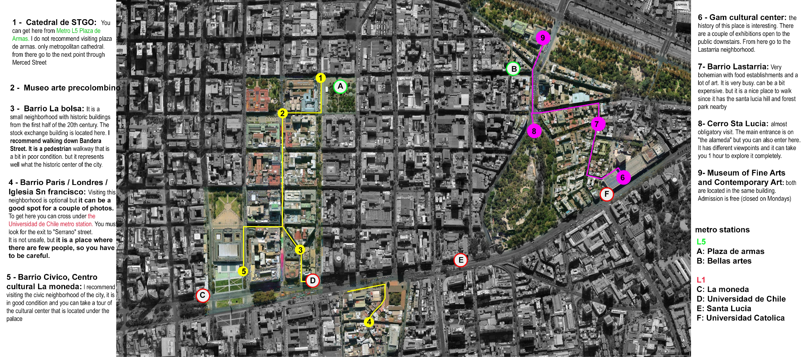

In downtown Santiago, there are lots of old buildings and churches. But it’s better to go with a local or a guide so they can explain things.
The city center is quite safe during the day. Just don’t go around flashing expensive stuff like luxury watches or jewelry and keep your phone and wallet mostly in your pocket. Also don’t go there when the sun goes down. This has a small exception that is Barrio Lastarria. It’s within the city center a small area which is fine during the day and night also and is very beautiful and has lots of restaurants and bars to hang out.
Palacio de la Moneda - former mint - presidential palace - cultural centre - courtyard - daily Changing of the Guard

Museums
Museo Chileno de Arte Precolombino - Plaza de Armas. 10-6 Closed Monday. Has English audioguide.

Museo Nacional de Bellas Artes – free museum. If you happen to be passing by and they’re open, they’re worth a visit. Lastarria. Near a nice park, Parque Forestal. 11-7:30 Closed Monday. English? It's art shouldn't matter.

Museo Historico Nacional - free museum in a former palace, now the post office building. Plaza de Armas

Museo Nacional de Historia Natural - also free - in Parque Quinta Normal

La Chascona Pablo Neruda house - Mirador Pablo Neruda is a great option. Besides exploring the historical museum and Pablo Neruda’s house, you’ll have an excellent vantage point to take in the city’s views. Bellavista. Open 7 days a week. 10-6 has English audioguide. Two other Neruda houses in Valparaiso and Isla Negra.

Gabriela Mistral GAM cultural centre - Lastarria

Museo Ralli Santiago near Costanera (where our airbnb is). Entrance is free. The Museum opens from Tuesday to Sunday between 10:30 a.m. and 5:00 p.m. It opens only on weekends in January, and it closes in February.

Bahai Temple
Closed Mondays.

https://www.myguidechile.com/travel-articles/everything-you-need-to-know-before-visiting-the-bahai-temple

Built 2016. Interesting architecture. In the mountains.
Unmissable visit in the city of Santiago. Getting there is very easy and inexpensive. To get here, take metro Línea 4 to the Grecia station, catch bus 506 to Diagonal Las Torres and then walk north along Alvaro Casanova to the temple access road. It's a tough uphill walk, so you may prefer a taxi. The temple is unique, spectacular, and has a unique structure. The view of the whole city is certainly unforgettable.

According to Google Maps, from Tobalaba Metro - 12 minute metro - 15 minute bus - 35 minute walk.

In the same vicinity, could combine - guided walk with a naturalist (4h, too long?) Parque Natural Quebrada de Macul
https://www.guruwalk.com/walks/49643-get-to-know-chile-s-nature-one-step-away-from-santiago

Churches
Catedral Metropolitana - at Plaza de Armas - free - busy - “stunning floor tiles and frescoed ceilings”

Iglesia San Francisco - Barrio Paris Londres - oldest building in the city

Parks

Cerro Santa Lucia
just at the edge of downtown, is a park centered around a huge hill that offers great views all over Santiago - You can walk up to the top of the hill in half an hour.

Cerro San Cristobal
The view from there is amazing, you can see the whole city. Try the mote con huesillo while you’re there (it’s a sweet drink with peaches and wheat; some people love it, some don’t). Start your walk from Pedro de Valdivia Norte, it's safer.

You can walk up or bike up.

Funicular in Parque Metropolitano

Cable car teleferico.

Piscina Tupahue closed for maintenance?
Piscina Antilen. Permanently closed

Other parks
Forestal - just behind downtown and adjacent to the neighborhoods of Bellas Artes and Lastarria is a long park with manicured lawns, a whole variety of trees and plants, and countless benches and places to sit and relax. There are even restaurants in the park. Site of Museo Nacional de Bellas Artes

Parque Bicentenario - large park opened 2007 - network of public parks that extend along the river

Araucano - across from a high end shopping mall - has roses

Quinta Normal - east of centre - Yungay neighbourhood

Japanese garden, in Metropolitan Park (Cerro San Cristobal)

Sky Costanera
Close to our apartment - viewing deck a la CN tower or Empire State. Maybe.

Go after rain - there is no smog immediately after the rain and the view will be much better.

Neighborhoods overview
https://www.chile.travel/en/travel-log/take-a-tour-of-santiagos-heritage-route-and-walk-around-the-most-beautiful-parts-of-the-capital/

Las Condes: Las Condes is an up-market, mainly residential suburb, but also home to many modern offices and good restaurants.

Barrio Italia: Lively, with restaurants and bars,

Bellavista: touristy, bars. Also La Chascona, the former home of the famous poet Pablo Neruda

Barrio Concha y Toro: Historic, heritage-designated neighborhood in Santiago, Chile, known for its elegant mansions, cobblestone streets, and beautiful architecture, including Neoclassical, Gothic, and Beaux-Arts styles. It was created in the 1920s from a former estate and became a hub for artists and intellectuals.

Barrio Lastarria: Barrio Lastarria is a lovely neighborhood with great places to eat and shop. I stay in that neighborhood when I’m in Santiago. Very walkable. For a chill afternoon, walk around Barrio Lastarria. It’s a quiet area with cafes, art galleries, and small shops. Also home to Centro Gabriela Mistral cultural centre

Barrio Paris-Londres: Today, one can still walk through its narrow cobblestone streets and observe the artistic details on iron railings, eat at restaurants on the sidewalks, and feel as if you were in Paris or London

Yungay:

Avoid
avoid crowded places like Estación Central or Bellavista cause you're probably gonna get robbed (especially in Estación Central) but if you move around Providencia, Ñuñoa, Las Condes or Vitacura you are pretty safe. One very good place to go is Bicentenario Park (near Tobalaba metro station), a beautiful park and 100% safe.

Providencia, Las Condes, Ñuñoa and La reina are pretty safe in general

Santiago is currently a city with a lot of street vendors, 60% of that street vendors are foreigners. Never buy food on the street. Maybe only "mote con huesillo" which is a traditional Chilean drink.
You can visit Barrio Italia by Uber
Metro A (red line) is perfectly OK for getting around (just avoid rush hours). Other options are Didi (cheapest), Uber or Cabify (most expensive). Stay out of the centro after 20h, it gets empty around that time.
Avoid La Vega Central (it’s not very safe) or Patronato
Don’t take taxis from the streets, use Uber or Cabify. The taxis are known to scam people, especially tourists.
Las condes and vitacura are safe even at night. In vitacura during the day you can go to Parque Bicentenario and close to it is avenue Nueva Costanera Avenue which is very nice and upscale you can find many nice restaurants and a small but classy shopping mall (Casa Costanera). Also the zone known as BordeRio, in Vitacura at the shore of the mapocho river has many nice restaurants. Las condes is nice but not much happens during the night you can go during the day to parque araucano and walk the area a bit. Providencia is safe during the day a bit less during the night . Barrio Italia has many nice restaurants and has a more bohemian vibe.

Day trips

Viña del Mar and Valparaiso
Moved to Day trip to Valparaiso.

Cajon del Maipo?
Try to go to the outskirts like Cajon del Maipo, or for a day.
Cajón del Maipo – I found one from Get Your Guide that takes guests to the thermal pools and does barbecue. This is for sure the highlight of my trip. I enjoyed bathing and had my fill with food and wine.
https://atlasobsession.com/el-cajon-del-maipo/ - she didn’t really like her tour
Termas Valle de Colina
https://www.tripadvisor.ca/AttractionProductReview-g294305-d13567374-Small_Group_Tour_Cajon_del_Maipo_with_Hotsprings_and_Picnic_Includes_Entrance-Sant.html

Eat
Wonderland Cafe Lastarria (Alice in Wonderland theme; breakfast/lunch)

Galindo in Bella Vista - touristy?

Mercado Urbano Tobalaba - a nice-looking place very close to our apartment “Wow...you must go if you are in Santiago. You can go straight using the Metro/Subway. Nice, Modern, offering many options for eat and drink. This place is not a common mall and the objective is to have an open and green area in a developed area in a big city. You will be surprised.”

Bar Liguria Luis Thayer Ojeda - 2 minutes from our apartment and recommended by host

Barrio Italia for Peruvian for dinner and dessert at Café Cariño
pisco sours at Chipe Libre. Other notable watering holes or lunch options in the area (Plaza de Armas?): Liguria (especially for the 3-story tall bar and the old-school service!), Bocanariz (no), Salvador Cocina y Café, or,
Near Costanera, Ambrosia Bistro (in MUT)
Fuente Alemana, Easygoing operation with a terrace & a low-key vibe offering a menu of hearty sandwiches.
Tacu Tacu (Nikkei ceviche). - 12 minute walk from our place - “in the heart of the tourist area of Santiago”

